Development of Interactive Virtual Reality Educational Contents
for Middle School Students to Experience Earth Science Education

*Minha Park, **Jeongwon Na, ***Hyundam Yoon, ****Hyeyoung Ko

*, **Dept. of Contents Design, Seoul Woman’s university
*** Major. of Visual Communication Design, Seoul Woman’s university
****Dept. of Digital Media Design&Application, Seoul Woman’s university
621, Hwarang-ro, Nowon-Gu
Seoul, Republic of Korea
*minha1993@naver.com, **jwna950929@naver.com, ***dadi7259@naver.com, ****kohy@swu.ac.kr

Abstract

Technological advancement achieved by the 4th Industrial Revolution has brought many changes in education. Technologies such as Virtual Reality (VR)and Augmented Reality(AR), which have recently draw attention, are also incorporated into the education. VR in particular, has proven to be useful to enhance user's concentration towards content, by expanding their virtual experience through virtual space similar to real life. On the other hand, Korean students have lower interest and confidence in science learning than the international level. Therefore, Measures are needed for this. In this study, Using VR technology, we planned earth science educational VR content for middle school students with low interest in science. In order to improve the efficiency of production, VR contents design method was established and contents were designed based on this. Earth science education, which requires concepts and understanding of principles and is difficult for students to directly experiment or observe, will create synergies with the characteristics of VR and provide an opportunity to increase students' interest in science.

Virtual Reality; VR; Earth Science Education; Experience Education Contents

I. Introduction

Science is an important subject to solve the everyday life problem creatively and rationally by cultivating scientific exploration ability and attitude[1]. However, it shows that South Korean students’ interest and self-confidence in science class is very low, compared to international standards[2]. In particular, moving up to middle school and high school, the level of excitement and enjoyment in science is continuously reduced. The biggest reason for this phenomenon is that most of the middle and high school science classes are mainly driven by memorizing textbook. So, improving traditional education system is needed to improve student interest and confidence in science. Recently, Technology development by the 4th Industrial Revolution changes the field of education a lot, so the VR technology is combined to the education field. Because, it is effective to give a sense of immersion to learning through experiential centered education, and it can enhance leaning effect through interaction in virtual space. In this paper, we will construct educational contents that is about the Solid Earth Science among the Earth Science to apply VR technology, and we will organize the contents, establishing the VR design method.

II. Research for Base

A. Analysis of Existing Earth Science Education

Elementary, middle, and high school science education is included in the science educational curriculum(National Curriculum) of the Ministry of Education, Science and Technology. Among them, the ‘Solid Earth’ section is divided as below [TABLE I]. It is common that they are learning the content of the 'Solid Earth' in the curriculum of elementary, middle, and high school science, by difficulty level. And it shows its importance.

TABLE I
The Solid Earth part in Earth science for elementary, middle, high school.

Category |  |  |  |  | Key Concept |  |  |  | Learning Content
Elementary school |  |  |  |  | volcano and earthquake |  |  |  | Understanding that volcanic activity and earthquakes have a large impact on people, such as harming people and property
 |  |  | The shape of the earth |  |  | Understanding the features of the earth we live in and the characteristics of the earth, sea, and air
Middle School |  |  |  |  | Changes in geosphere |  |  |  | Understanding the nature of the material that makes up the Earth's internal structure and indicators.
High School |  | General Science |  |  | System of the earth |  |  |  | Integrated Understanding on the features of the earth in a systematic way as an optimal environment for living creatures
 | Earth Science I |  | Fluctuation of the geosphere |  |  |  |  | Understanding the surface of the earth is constantly changing.
 |  |  |  | History of the earth |  |  | Understanding the earth's environment and creatures have constantly changed over the geological period
 | Earth Science II |  | Formation of the earth and field of force |  |  |  |  | Understanding the formation and evolution process of the solar system, identify the internal structure revealed through seismic waves, and understand the characteristics and changes of gravity and magnetic fields.

B. Education VR Contents Example

Recently, VR education contents that can experience the space or era which is difficult to experience in real life are appearing. For example, the universe, undersea, dinosaur and the human body. In addition, it is actively used in fields with high training value, such as medical and firefighting education, while reducing risk factors through simulation. The following is an example.

a) Medical education content "Osso VR - Virtual Surgery"[3]
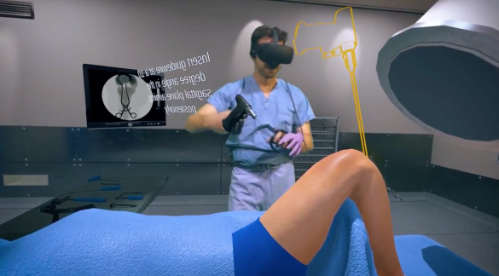
Fig. 1 Osso VR - Virtual Surgery

Osso VR is a surgical education platform. As shown in [Fig. 1], the user can hold a virtual surgical instrument by hand, so it suggests user the actual surgical procedure vivid. This has the advantage of being able to experience and practice practically difficult situations in the actual operating room. Currently, surgical training for orthopedic spine treatment is available and is being expanded and used in various medical fields.

b) Fire fighting education content "Fire Fighter VR"[4]
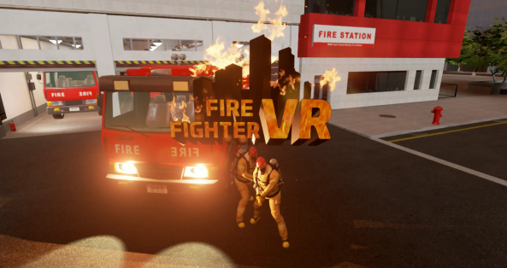
Fig. 2 Fire Fighter VR

<Fire Fighter VR> is a virtual fire experience contents developed by MWN Tech. It can be played using OculusRift and a proprietary hose controller. It consists of seven fire suppression scenarios, two fire evacuation scenarios, fire extinguisher usage, and a rigger usage. Because it is dangerous to actually experience a fire situation, systematic contextual content design is characteristic in order to experience a virtual fire situation. This can be used as useful fire training materials to prepare for various fire situations.

C. Digital Earth Science Educational Content "The Lab - Solar System" Case[5]
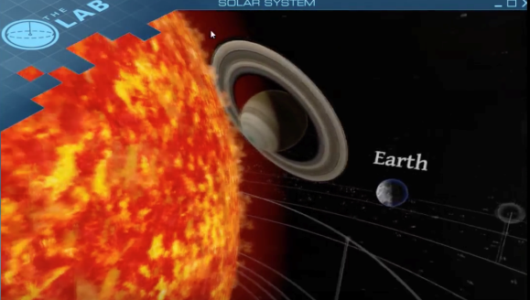
Fig. 3 The Lab - Solar System

<The Lab - Solar System> is a virtual reality video game developed by Valve and plays with HTC Vibe device. This is the theme of the solar system. It can see and select the planets that are circling around the sun and can move arbitrarily. Also observe the huge sun nearby. It has the advantage of displaying the universe as real. However, there is no information or explanation other than the name of the planet that appears when each planet is selected, so there is a limit to learn earth science. In addition, there is no interaction other than capturing the planet, which makes it is not helpful to cause interest.

III. Project Planning

This project has designed science education content using interactive VR technology for middle school students to make them easily understand and effectively learn the Earth science subject.

A. Target Analysis

The primary target of this project is a middle school student who is 13-15 years old. Since this period corresponds to the adolescent period in which the concentration is lacking, the learning method using the virtual reality technology can increase the learning efficiency by giving a feeling of immersion. In addition, it is a time to be free from the university entrance examination burdens in comparison with high school students, and an opportunity to increase interest and curiosity in science.

B. Contents of Education

TABLE II
Contents of Education

Category |  |  |  |  | Key Concept |  |  |  | The element of contents |  |  |  | interactive learning
The Solid Earth |  |  | History of the Earth |  |  |  |  | Learning the Birth Process of the Earth
 |  | Formation of the earth and field of force |  |  |  | Earth's layered structure (crust,mantle, outer core and inner core in the earth) and learning of Magnetic field concept |  |  |  | Earth's layered structure
 |  |  |  |  |  |  |  |  |  |  |  | Magnetic field
 | Plate tectonics |  |  |  |  |  | Learning of the Earth’s surface consists of several plates and the concept that earthquakes and volcanoes occur at plate boundaries |  |  |  | Earthquake
 |  |  |  |  |  |  |  |  |  |  |  | Volcano

a) History of the Earth

Vivid 3D images in virtual reality make it possible to see and understand the birth process of the earth.

b) Earth's layered structure

The learner moves his or her hand directly to cut the earth and take out the crust, mantle, outer core and inner core in the earth, grasp each position and learn the feature, also make effective learning according to the operation speed of the user.

c) Magnetic field

This allows the learner to directly learn the principle of force by directing the solar wind to learn the change of the magnetic field.

d) Earthquakes

The learner chooses the origin to make it easy to understand the process of earthquake and the P-wave and S-wave

e) Volcano

The learner can easily understand the principles of volcanoes by letting the magma in magma jump directly up and learning the process of volcanic eruption

C. Flow Chart and Interface Design

a) Flow Chart

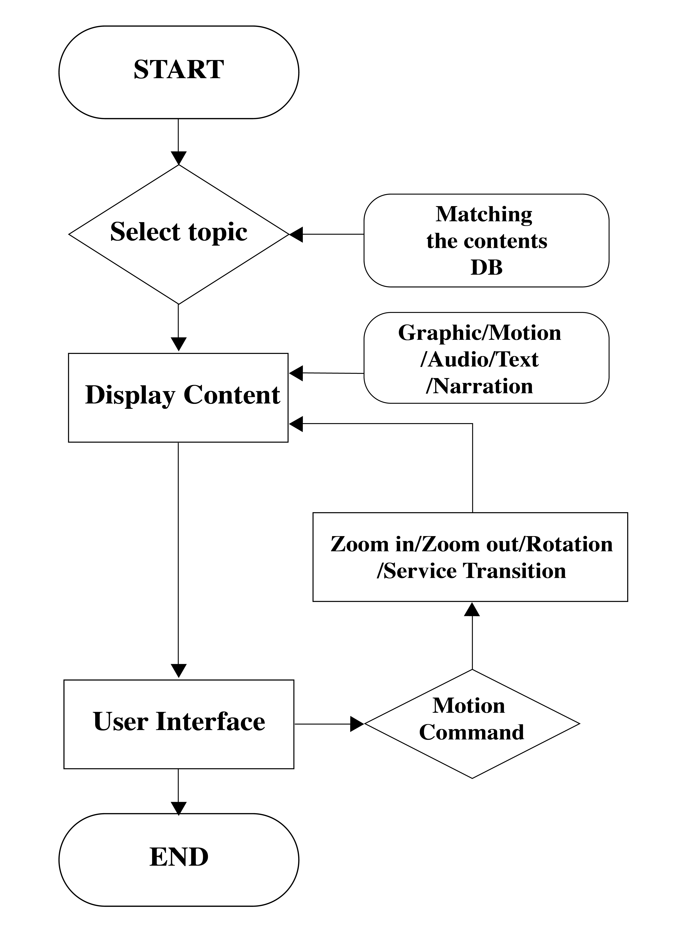
Fig. 4 Flow Chart

b) Interface Design

In this project, the screen design method suitable for VR contents implementation is made so that the front, top, bottom, right, and left screens are all included in the blueprint based on the visual field viewed by the learner through the HMD. In addition, the screen-specific information is classified into Graphic, Motion, Audio, Narration, and Text, and the description is numbered according to the appearance order so that no interference occurs during the actual development process. User Interaction includes a description of the interaction learning that the learner can move by hand.

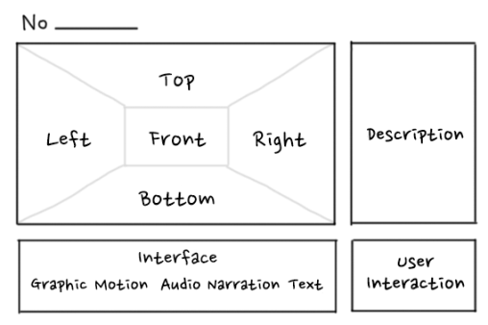
Fig. 5 Sketch of Interface Design

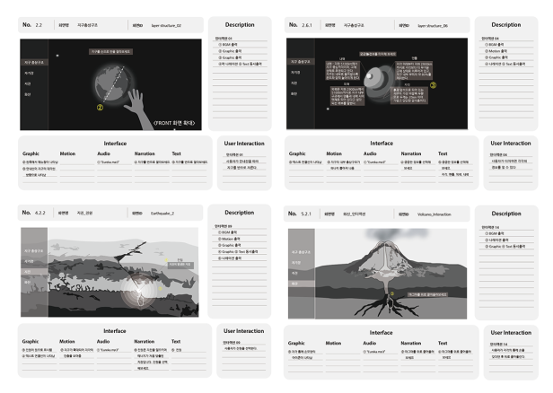
Fig. 6 Interface Design

D. Implementation Content

In this project, learning contents are divided into Earth's layered structure, magnetic field, earthquake, and volcano. In the intro, the video of Earth's history begins with the universe of meteorites falling. After one of the meteorites has left its course and collides with the user, the initial earth is created, and the early earth gradually appears today. ① The earth stratified structure will be guided by the guideline of the part to be cut, and it will be implemented so that the structure inside the earth can be observed by selecting the cutting surface again after the motion to cut. ② The magnetic field will be implemented so that the length of the solar wind can be adjusted assuming that there is sun at the position of the user's hand. ③ The earthquake will be implemented so that the user can select the origin and observe the effect of the wave on the epicenter. ④ The volcano will be implemented so that the user can observe the explosion of the volcano by clicking and dragging the black part of the 2D magma.

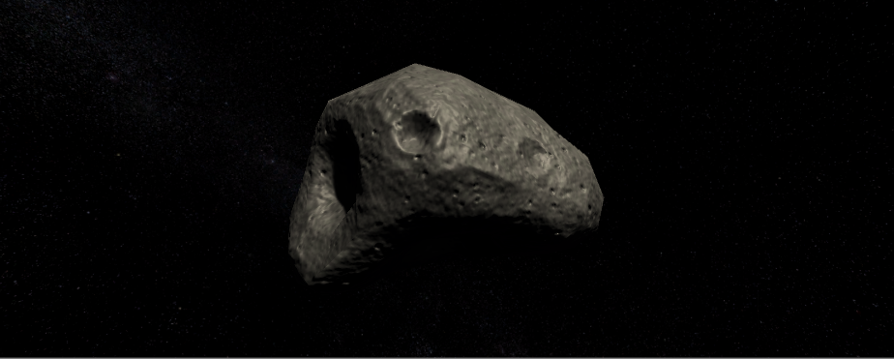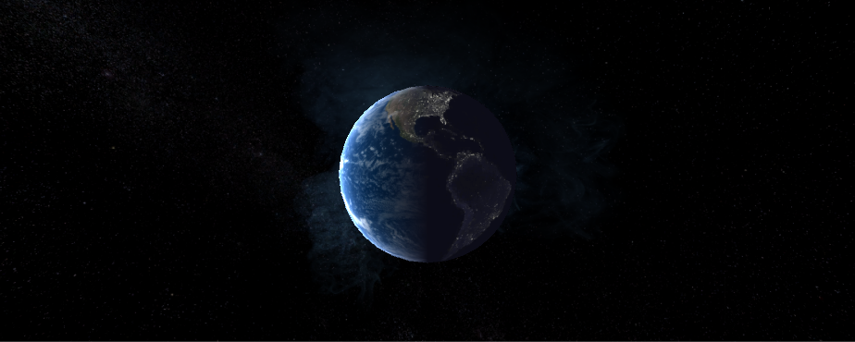
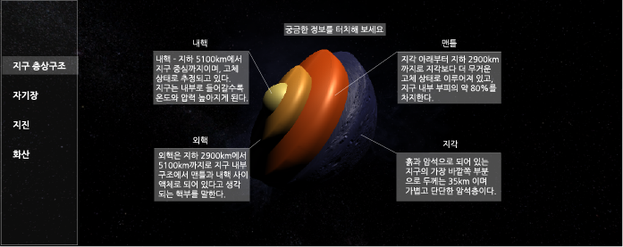
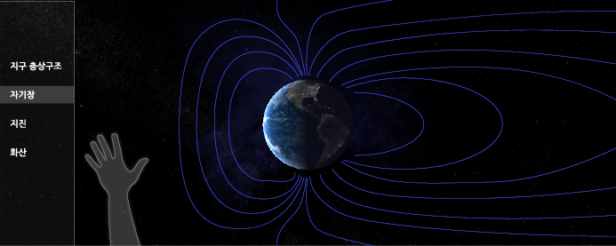
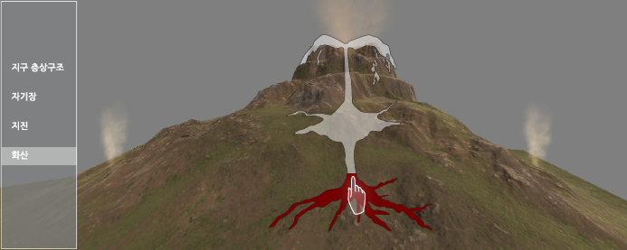
Fig. 7 Implementation Content

E. Implementation technology

The production technology of this content is as follows. First, 3D graphics images can be realistically implemented using Unity, a game engine. Second, HMD equipment uses Oculus lift and provides a first-person immersive virtual reality environment. Third, the learning effect is enhanced by allowing the learner to interact with the learning contents using the lip motion, which is a motion recognition device.

TABLE III
Education Equipment

Equipment
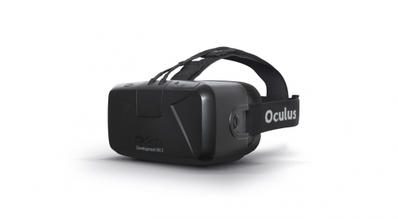 | 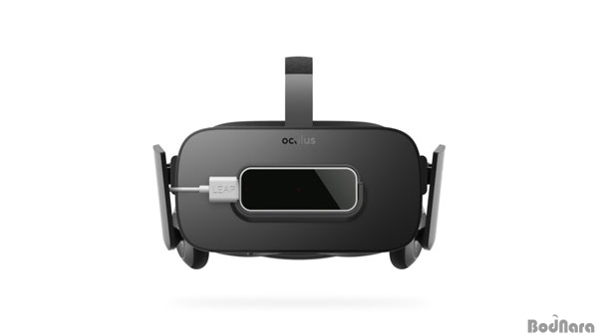  Oculus Rift  + Leap motion
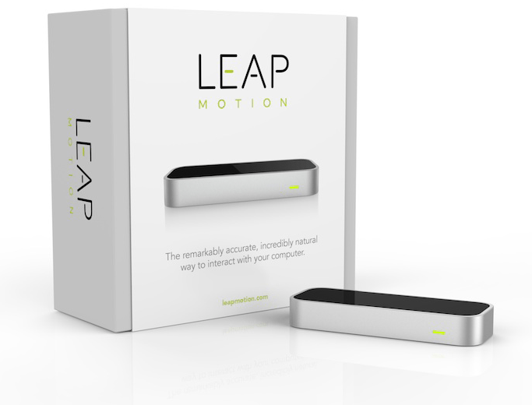

IV. Conclusion

The purpose of this study is to design educational content for Solid Earth in order to produce effective educational contents that incorporate VR into middle school students' earth science education, and to establish a VR design through systematic construction of implementation elements so that joint development can be made in VR production. Based on this, we have planned and proposed educational contents that combine vivid 3D stereoscopic image and interaction. The advantage of this content is that the learner interacts in the direction of the force acting directly, so he can understand the principle of force while seeing visual and physical changes. In addition, the speed of learning can be adjusted according to the level of understanding of the learners, which leads to the advantage of being able to lead learning and experiencing in real life. It will be interesting to concentrate on learning, and it will be educational contents that can increase interest in earth science learning which is impossible to experience in actual environment and improve learning effect effectively, and can be extended to other scientific fields.

Acknowledgment

"This research was supported by the MISP(Ministry of Science, ICT & Future Planning), Korea, under the National Program for Excellence in SW)(2016-0-00022) supervised by the IITP(Institute for Information & communications Technology Promotion)"(2016-0-00022)

References

[1] The Ministry of Education, “2015-74 The Science Educational Curriculum”, 2015
[2] Youngsun Kwak, Investigation of Elementary and Secondary Students' Interest in Science, 2006
[3]http://ossovr.com/
[4]https://mwntech.azurewebsites.net/products/fire-fighter-vr/
[5]https://youtu.be/W7CkAJrcXj4

